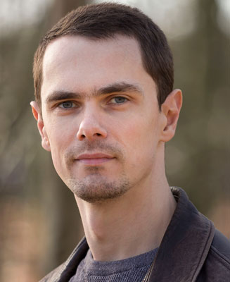
Mark Simkins
Location: Cambridge, UK
Height: 5'11” (180cm)
Weight: 11st. 1lb (70kg)
Waist: 32”
Chest: 42”
Physique: Slim/Athletic
Fitness: Good
Eye Colour: Blue
Hair Colour: Dark Brown
Hair Length: Short

Experience
(assorted stills on the following page)
Year | Type | Character | Production | Description | Company
2017 | Short Film | Mark | Birthday Girl | A birthday party doesn’t quite go to plan | Ruptured Screen
2017 | Micro Short Film | The Gardener | Astroturf | A man tends to his garden on the moon | Busy Doctors Films
2017 | Micro Short Film | The Man | Well Dressed Man | A man prepares for a life changing event | Cre8ive Spaces Ltd
2017 | Prosthetics Modelling | King of the Fish People | NA | Modelling for prosthetics training school | Gorton Studio
2016 | Music Video | Lead Victorian worker | Abusing My Position | Non-speaking dramatic boss confrontation | Ruptured Screen
2016 | Short Film | Motion Capture Actor | Take 28 | Non-speaking comedic 'behind the scenes' | Busy Doctors Films
2016 | TV Production | American Police, pub goer | Obsession | Two supporting artist roles | October Films
2016 | Short Film | Tom | Toby | Job interviewee by lead character | Professor Stamen
2016 | Feature Film | Stormtrooper | Star Wars: The Last Jedi | Stormtrooper supporting artist | Lucasfilm Ltd
2016 | Short Film Challenge | Guard / Doctor's assistant | Harvest | Two small non-speaking extra roles | Ruptured Screen
2016 | Prosthetics Modelling | Horned demon | NA | Modelling for prosthetics training school | Gorton Studio
2015 | Prosthetics Modelling | Birdlike tribal warrior | NA | Modelling for prosthetics training school | Gorton Studio
2014 | Prosthetics Modelling | Reptilian alien mercenary | NA | Modelling for prosthetics training school | Gorton Studio

Training
2015: Complete “Learn to Act” course with “in situ theatre” (15 weeks)
Skills/Other Experience
Vehicles: Car and Motorcycle
Musical Instruments: Trumpet/Cornet (experienced), Piano (basic)
Other: Firearms training (airsoft movement/room clearance training, real pistol range training in the US)
Karate (basic)

Assorted Stills
