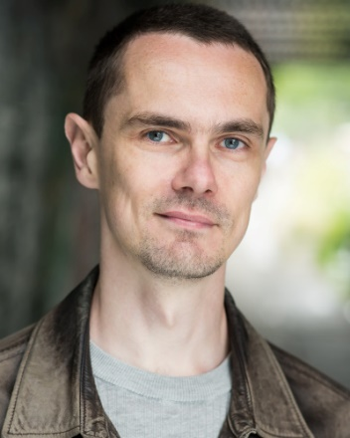

Mark Simkins
Location: Cambridge, UK
Height: 6’ (182cm)
Weight: 11st. 0lb (69kg)
Waist: 32”
Chest: 39”
Shoe Size: 9.5-10 (UK)
Physique: Slim/Athletic
Eye Colour: Blue
Hair Colour: Dark Brown
Hair Length: Short
Film Credits
Year | Type | Character | Production | Description | Company/Director
2020 | Short Film | Driver | Acceptance | US politician gets life-changing news before being elected | Mark Hampton
2019 | Music Video | Pig guard / Pig person | SWINE | Pig guard and pig person for “SWINE” music video | Giant Dwarf
2019 | Short Film | Peter | Patients | The lead character’s bad date | Ciaran McGhee
2019 | Short Film | Werewolf / Jason | After the Party | Guy becomes a werewolf in an attempt to date a woman | Rebecca Palmer
2019 | Feature Film | Major Felix Bor | Ivan | Polish Army Major discussing a case during the Cold War | Roland Oliver
2018 | Short Film | Denizen | Kiss of Death | Faceless hoodie monster stalking villain for vengeance | Dan Horrigan
2018 | Feature Film | Barkeep | Super Mix | Troubled but well-meaning post-apocalyptic bar owner | Joshua Armstrong
2018 | Short Film | Peter | Heaven | A man pushed to breaking point confesses his sins | Francesco Merlini-Fiore
2018 | Feature Film | Michael Melville | Dilemma | Man who reacts when his girlfriend cheats on him | Kokoe Film Productions
2018 | Feature Film | Cannibal Hunter (featured) | Edge of Extinction | Horde of post-apocalyptic cannibal hunters | Hundy Gilbert Media
2018 | Short Film | Dealer | The Gambler | Blackjack croupier at a hellish casino | Mill Road Films
2018 | Short Film | William | The Billionth Interview | Secretary for the life or death afterlife interview | Ron Mulvey
2017 | Short Film | Craig | Nemesis | Lead Debt Collector – fight scene + wire work | Nick Blair
2017 | Short Film | Evan | Positive Action | Health Minister PA, informing of zombie incident | Fingernail Films
2017 | Short Film | Mark | Birthday Girl | A birthday party doesn’t quite go to plan | Ruptured Screen
2017 | Micro Short Film | The Gardener | Astroturf | A man tends to his garden on the moon | Busy Doctors Films
2017 | Micro Short Film | The Man | Well Dressed Man | A man prepares for a life changing event | Cre8ive Spaces Ltd
2016 | Music Video | Lead Victorian worker | Abusing My Position | Non-speaking dramatic boss confrontation | Ruptured Screen
2016 | Short Film | Tom | Toby | Job interviewee by lead character | Professor Stamen
2016 | Feature Film | Stormtrooper | Star Wars: The Last Jedi | Stormtrooper supporting artist | Lucasfilm Ltd

Prosthetics Modelling
Year | Type | Character | Production | Description | Company/Director
2020 | Prosthetics Modelling | Cursed Fisherman | NA | Modelling for prosthetics training school | Gorton Studio
2019 | Prosthetics Modelling | Reptilian Demon | The Prosthetics Event | Modelling for Prosthetics Trade Show | Cantor & Nissel
2019 | Prosthetics Modelling | Half Transformed Demon | NA | Modelling for prosthetics training school | Gorton Studio
2019 | Prosthetics Modelling | Mutilated Witch | NA | Modelling for prosthetics training school | Gorton Studio
2018 | Photoshoot | Alien | Men in Black International | Promotional fashion photoshoot as an alien | Rose Line Productions
2018 | Prosthetics Modelling | Cyborg | NA | Modelling for prosthetics training school | Gorton Studio
2017 | Prosthetics Modelling | GI Zombie | NA | Modelling for prosthetics training school | Gorton Studio
2017 | Prosthetics Modelling | King of the Fish People | NA | Modelling for prosthetics training school | Gorton Studio
2016 | Prosthetics Modelling | Horned demon | NA | Modelling for prosthetics training school | Gorton Studio
2015 | Prosthetics Modelling | Birdlike tribal warrior | NA | Modelling for prosthetics training school | Gorton Studio
2014 | Prosthetics Modelling | Reptilian alien mercenary | NA | Modelling for prosthetics training school | Gorton Studio

Training
2018: “Firearms: Military & Tactical” with Independent Drama
2015: Complete “Learn to Act” course with “in situ theatre”
(15 weeks)

Skills/Other Experience
Vehicles: Car and Motorcycle
Musical Instruments: Trumpet/Cornet (experienced), Piano (intermediate)
Other: Touch typing, Real pistol range training in the US
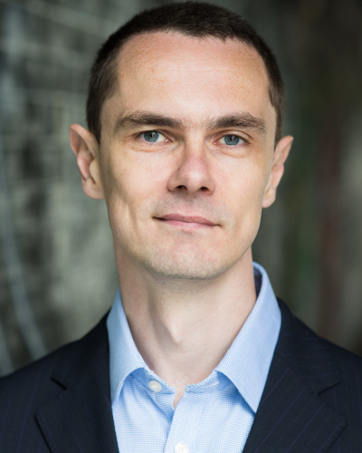
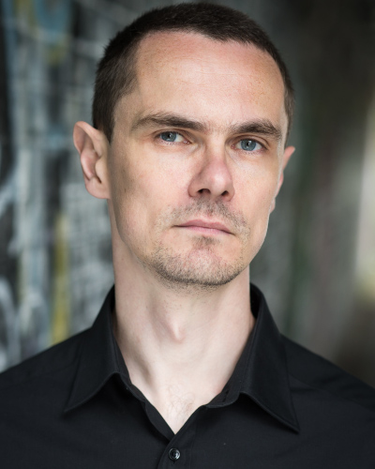
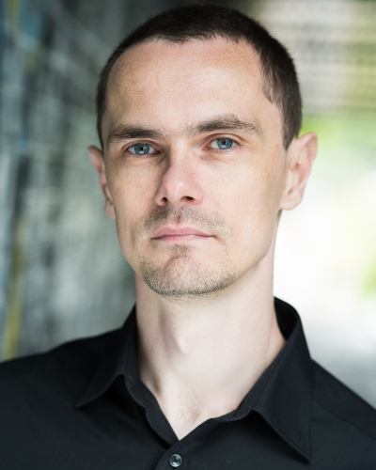
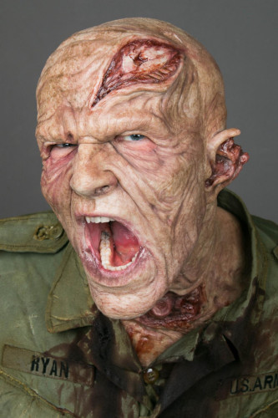
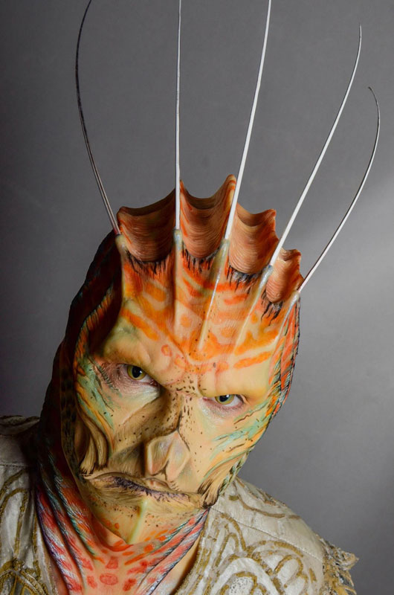
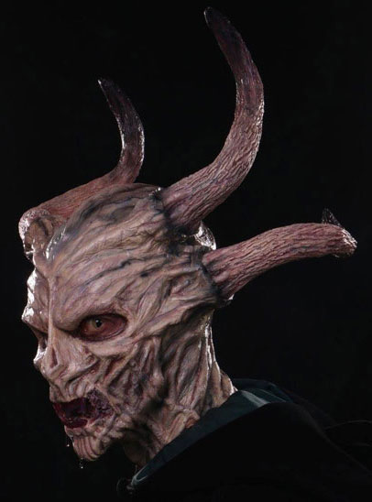
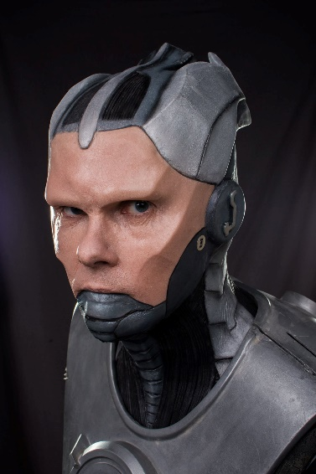
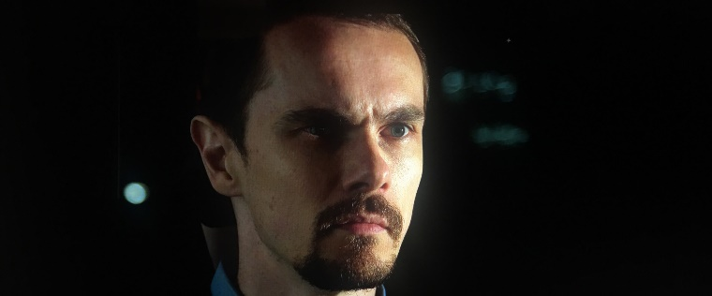
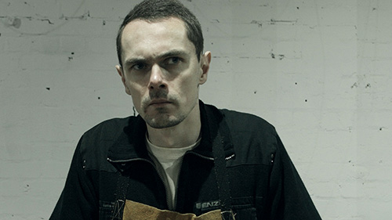
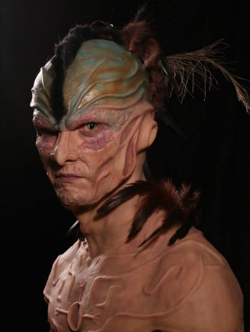
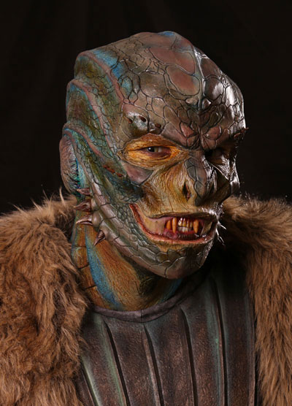
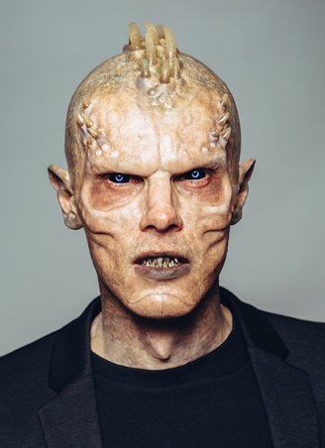
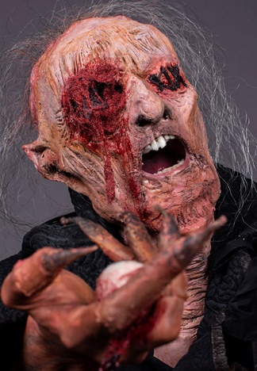
“Dilemma” (feature film)
“Super Mix” (feature film)

