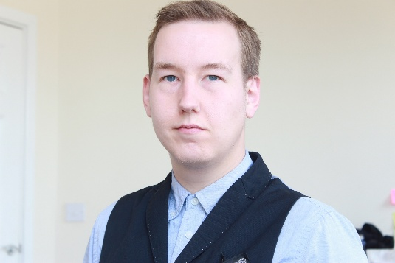

Robert Shiels

Education

Puppetry in performance – Little Angel Theatre / Oliver Smart - 2018

Movement Workshop – Frantic Assembly – 2009

Foundation Degree – Leeds Metropolitan – 2007-9

Production / Role / Year / Company / Medium

Curse of the lost tomb / Ratman/Hunter / 2018 / Immersive scare attraction

Various / Bumblebee / 2018 / Creature Events / Walkabout (Heavy Costume)

Shrek's Adventure / Shrek/Buddy - Princesses Poppy buddy / 2018 / Merlin / Immersive Theatre (Skin)

Get Familiar / Ensemble / 2016 / Bud Sugar (band) / Music video

Jon's Song / Jon / 2014 / Bud Sugar (band) / Music video
Link: https://jammerzine.com/bud-sugar-jons-song

Humber City / Mikey / 2012 / Peter Goundrill / Short

Safehouse / Weapon / 2011 / Four Thieves Productions / Film
Link: https://youtu.be/1nQlSHXUAWI

Four thieves and the not so sweet shop / Thief 4 / 2009 / Four Thieves Productions / Short
Link: https://vimeo.com/2192393e

Other experience

Creative media pinewood studios /Prosthetics model / 2018
-Applying silicone prosthetics
-Applying facial hair

Wawne show / Compere / 2015-2016

Bud Sugar / stage ensemble / 2015

Pacific Court Housing / model / 2009

Humberside police training (roleplay) 2007

